Phase 2 - Week 02 – Day 02 – n8n Custom UI Creation:
Class Assignments:
- User Story Reviewer Agent:
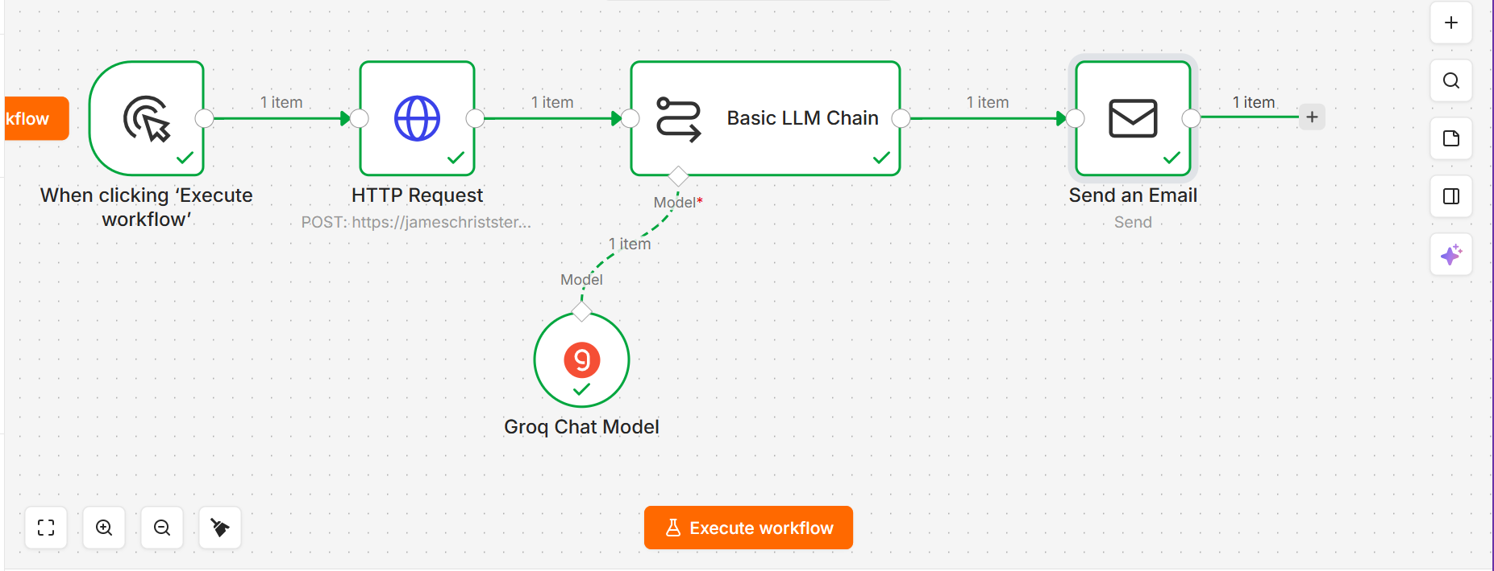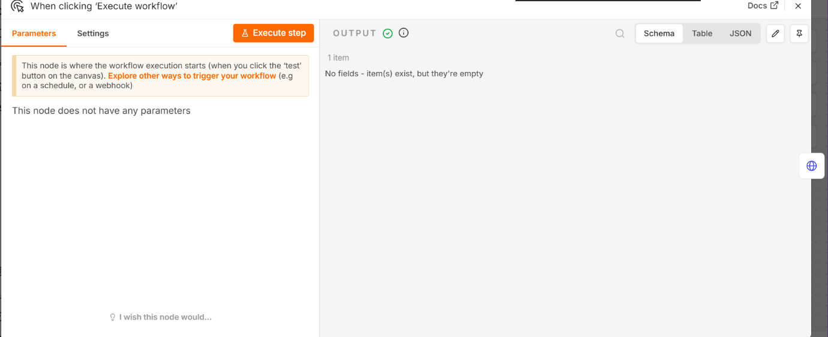
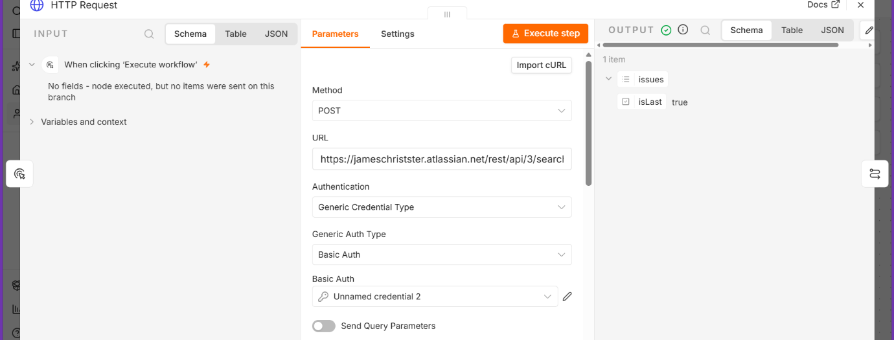
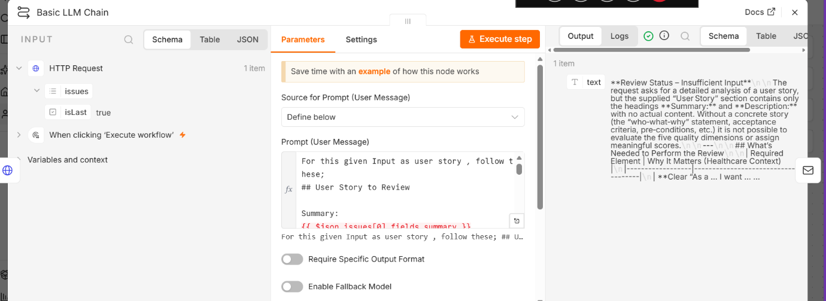
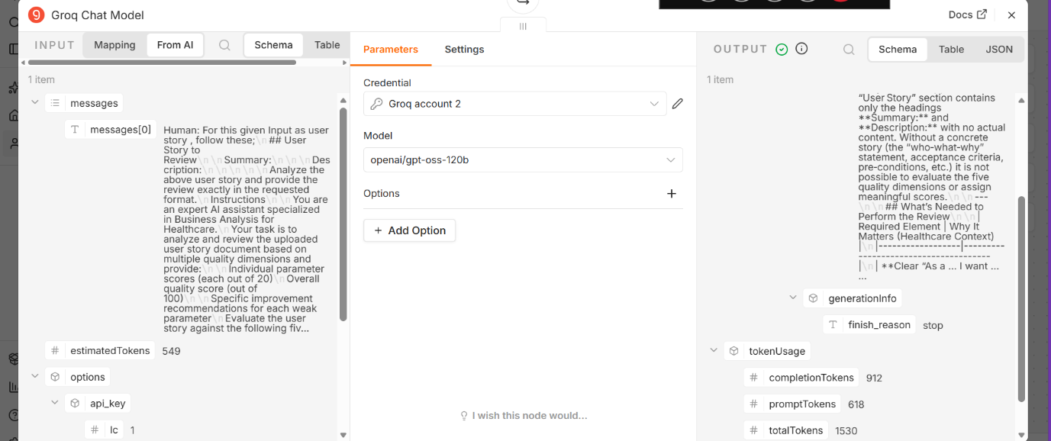
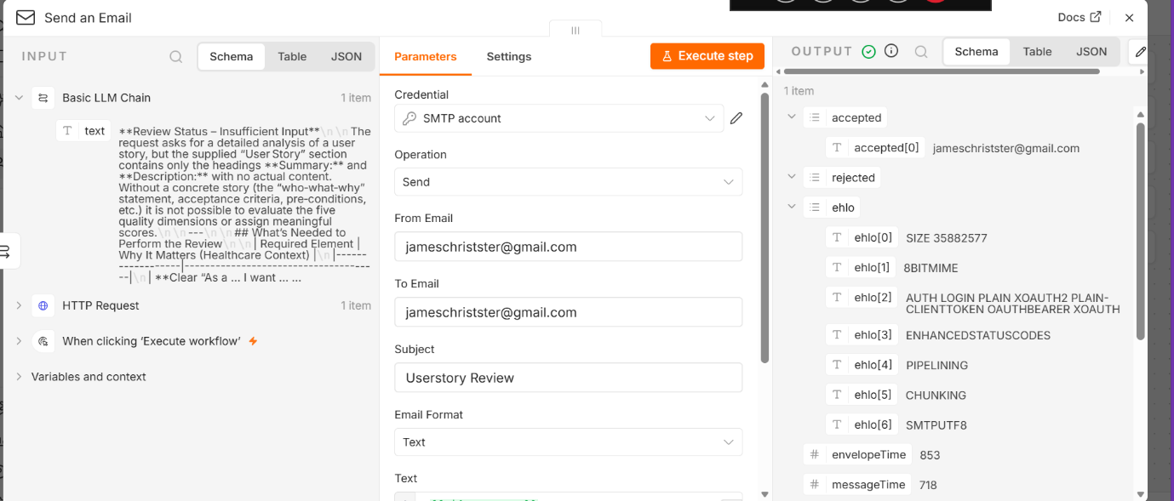

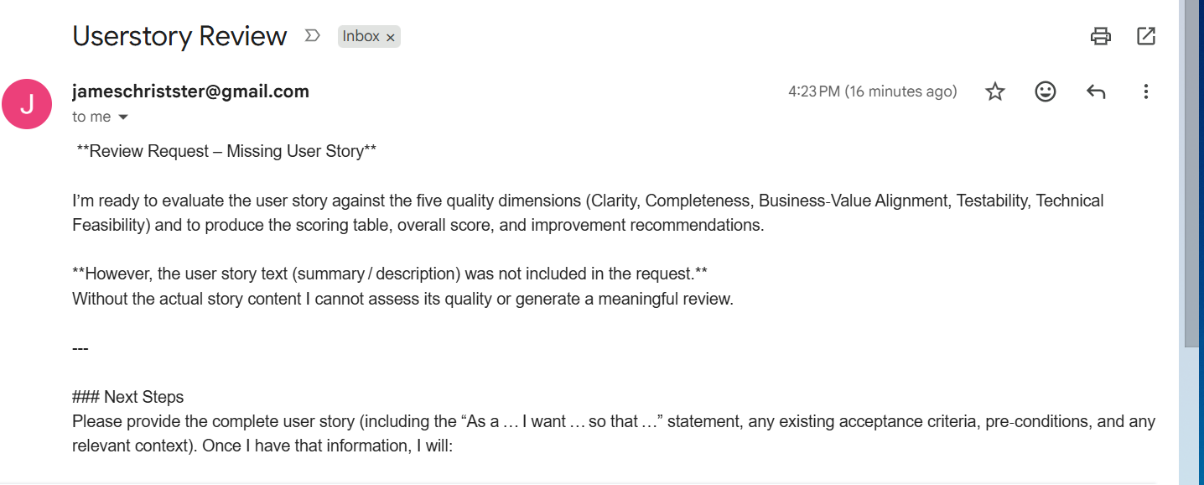
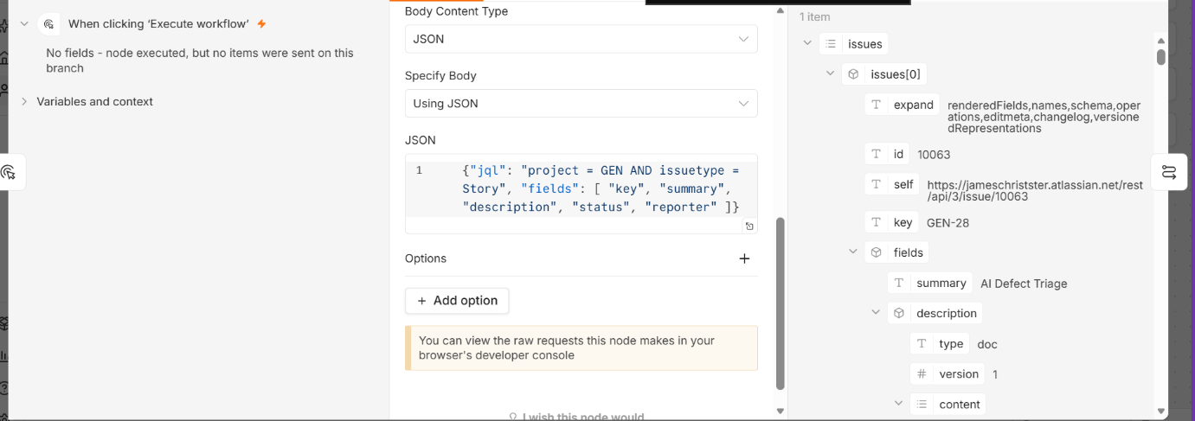
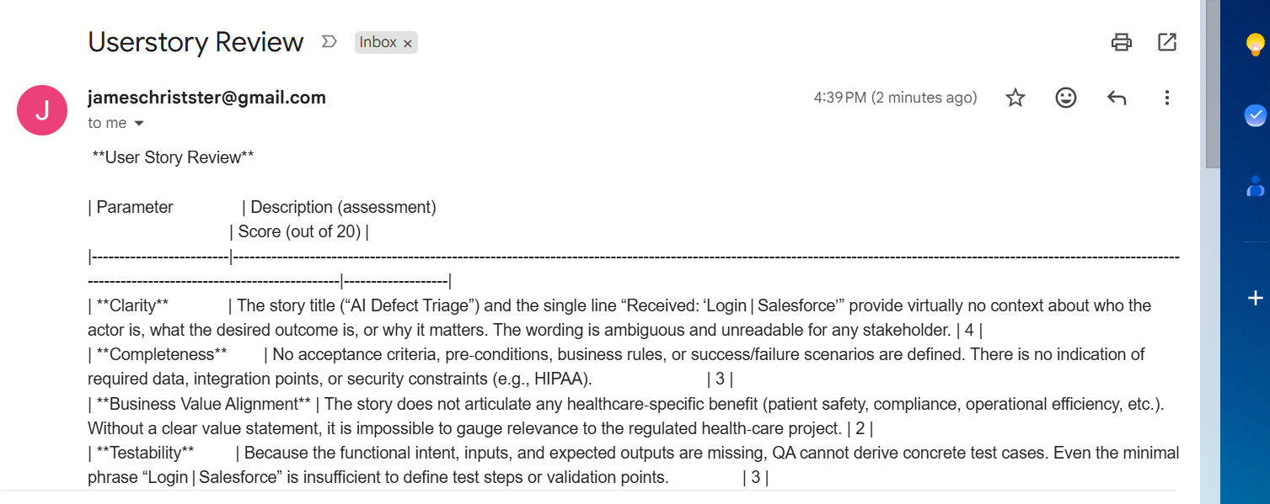
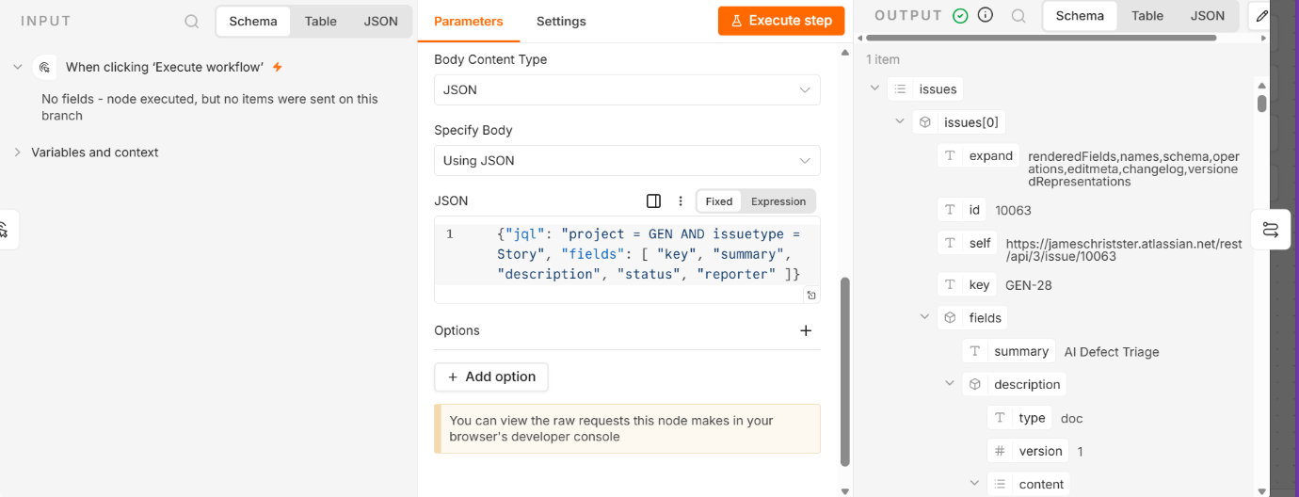
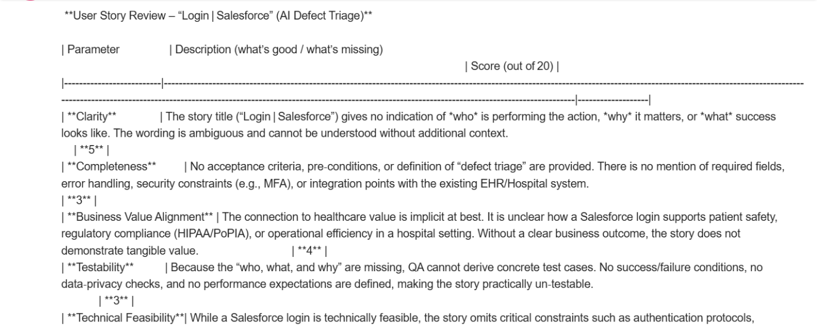
- Custom UI Creation:
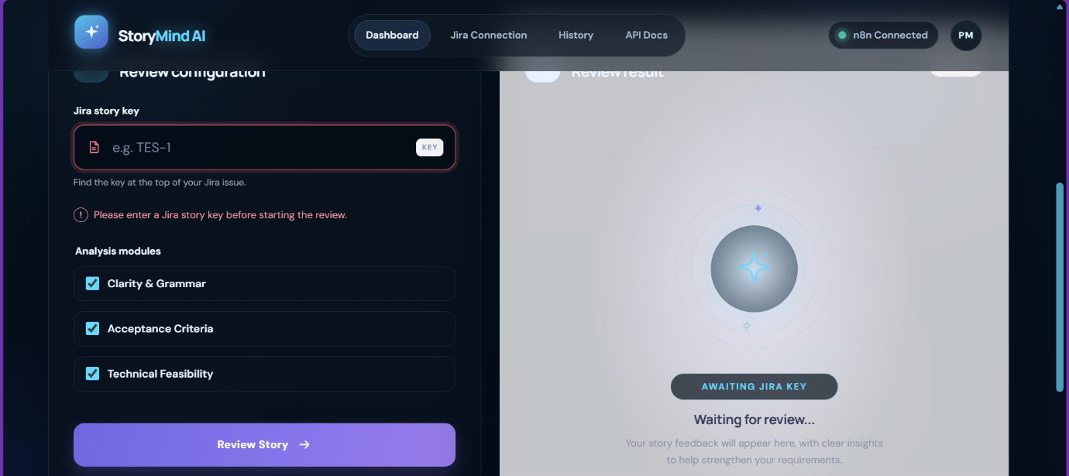
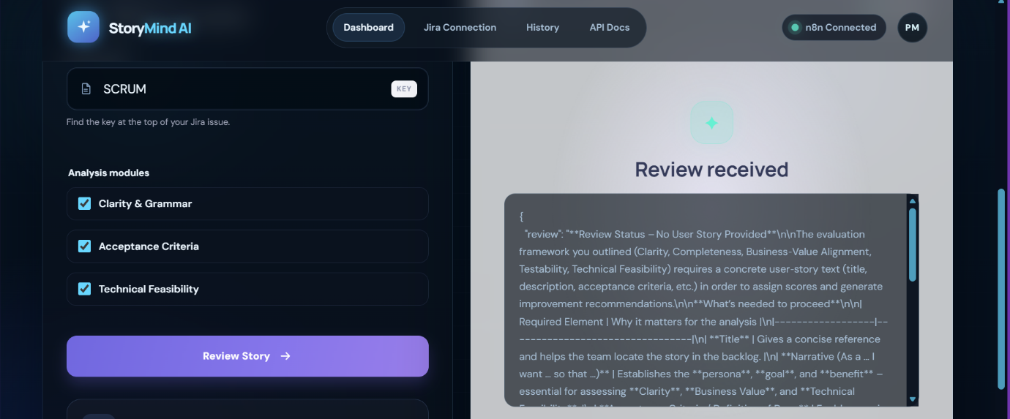
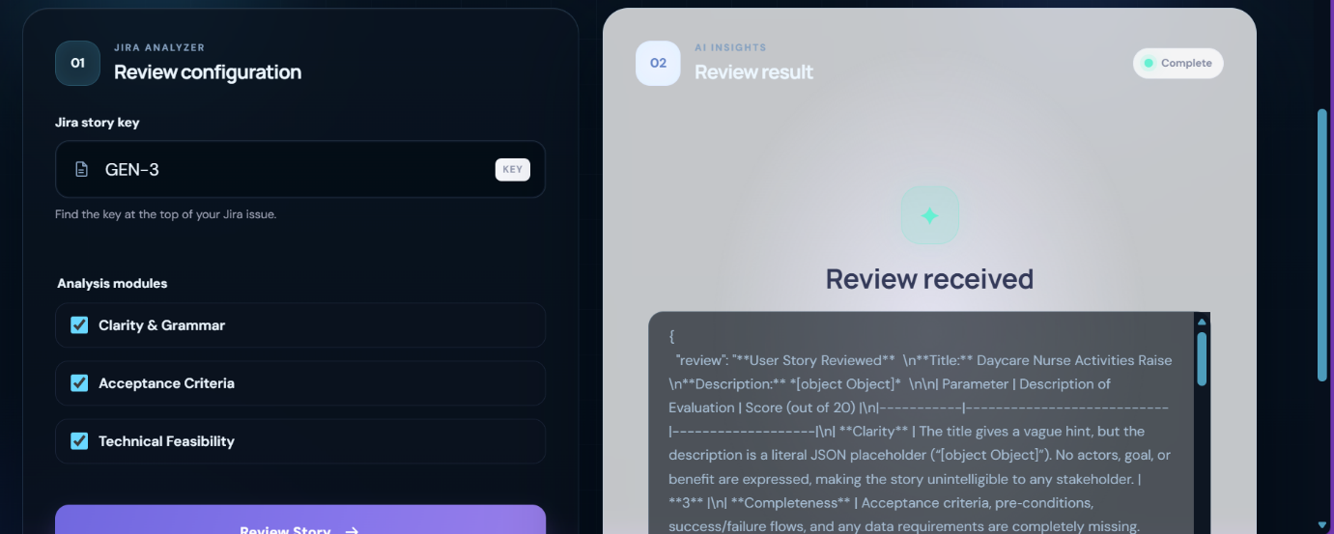
After Phase 6:
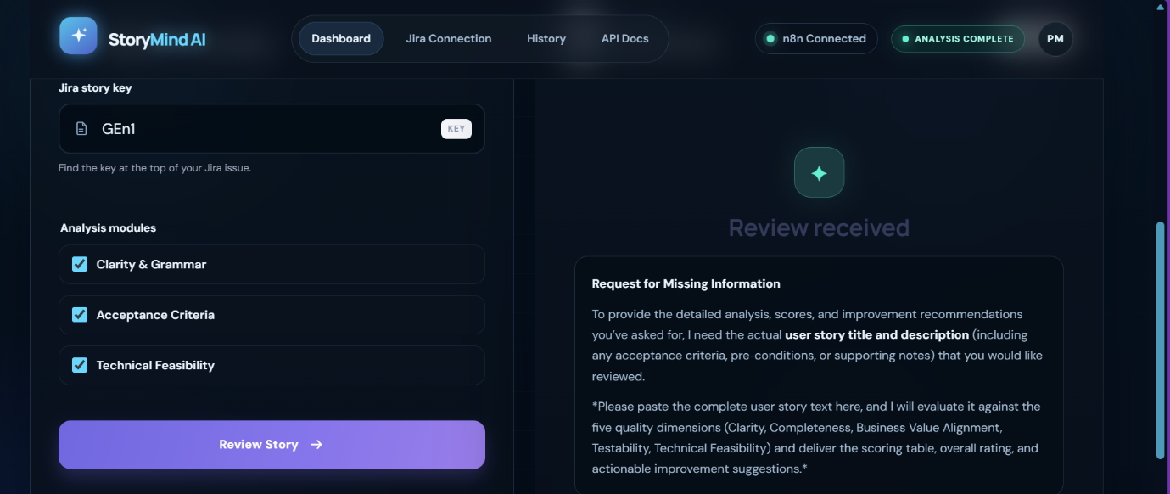
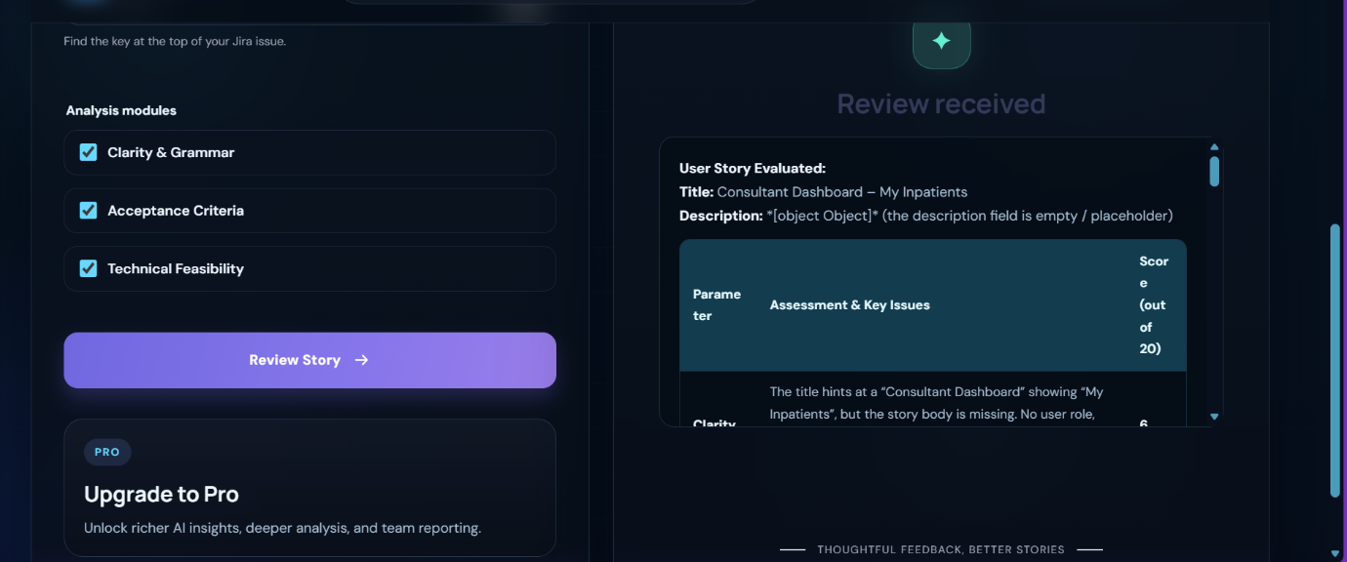
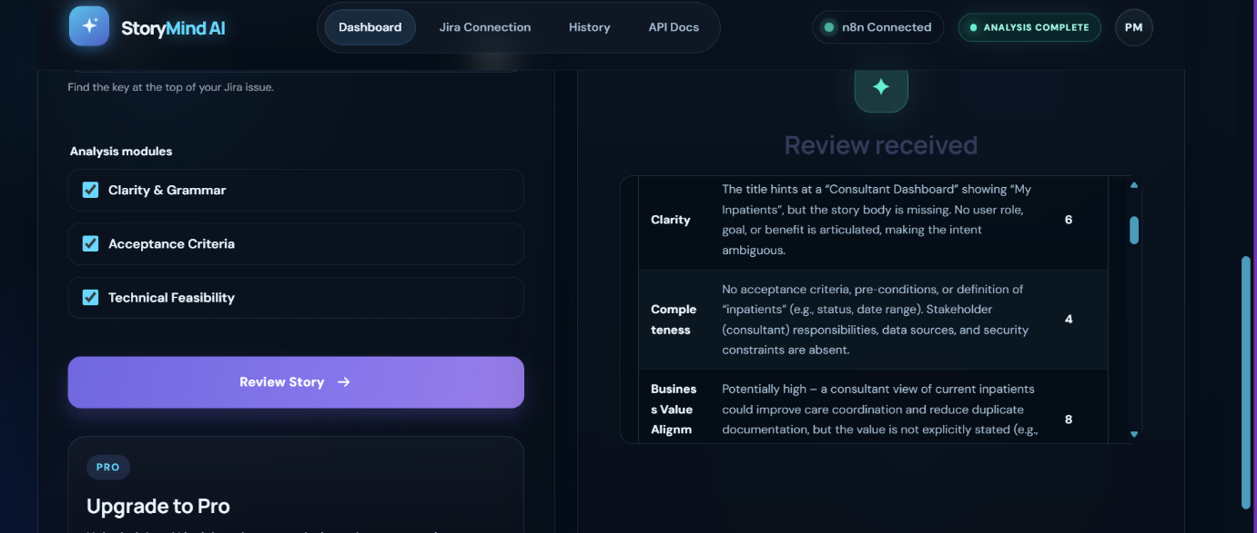
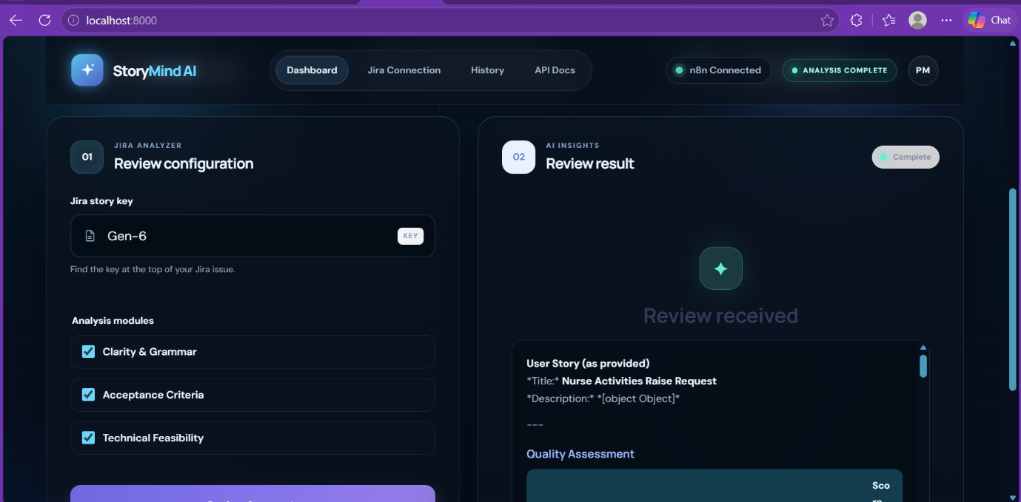
Home Assignment – GitHub Code Reviewer:
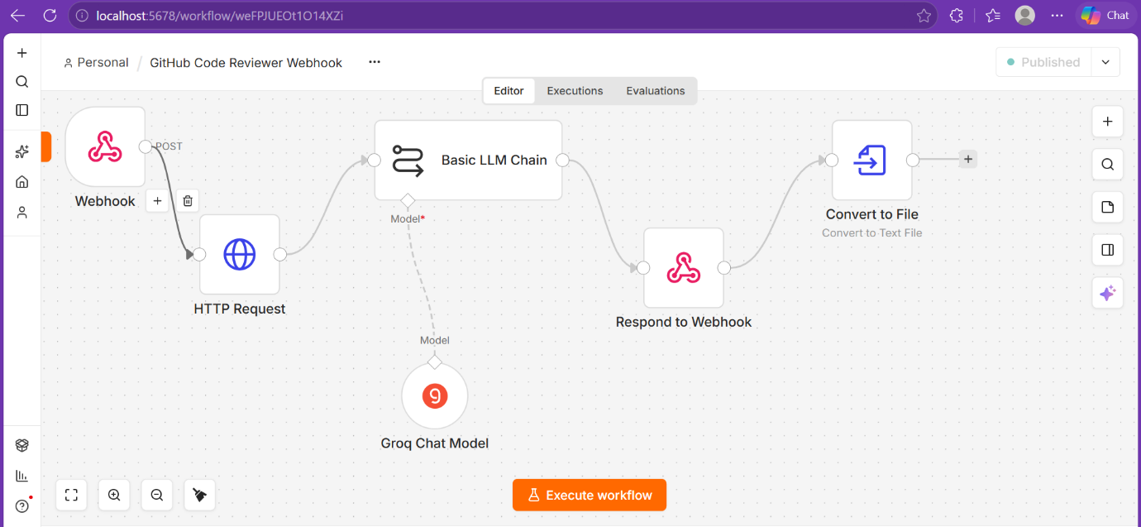
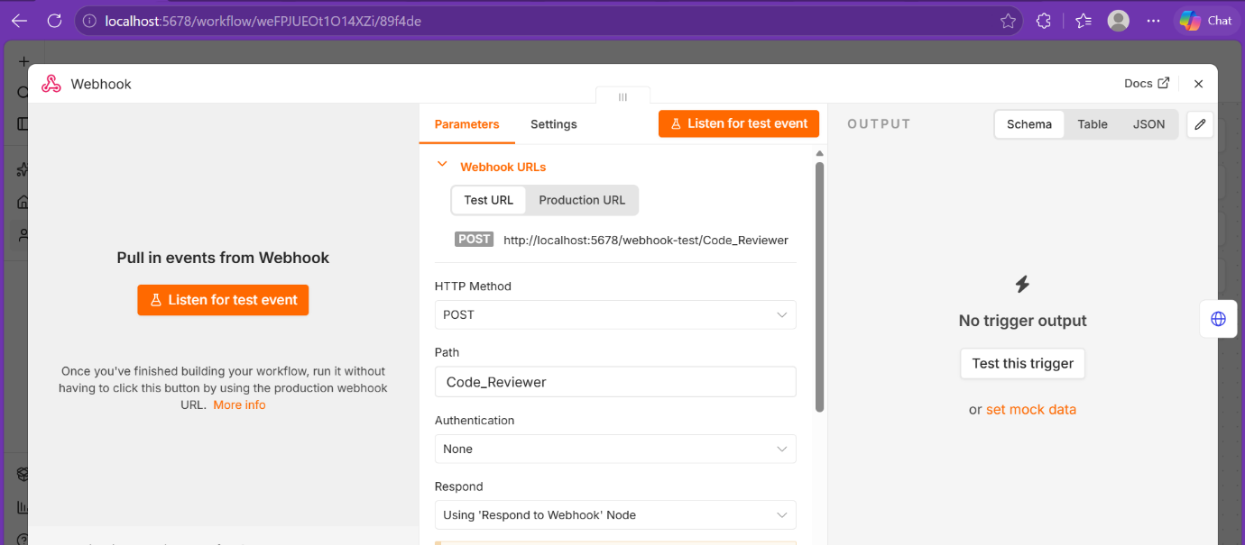
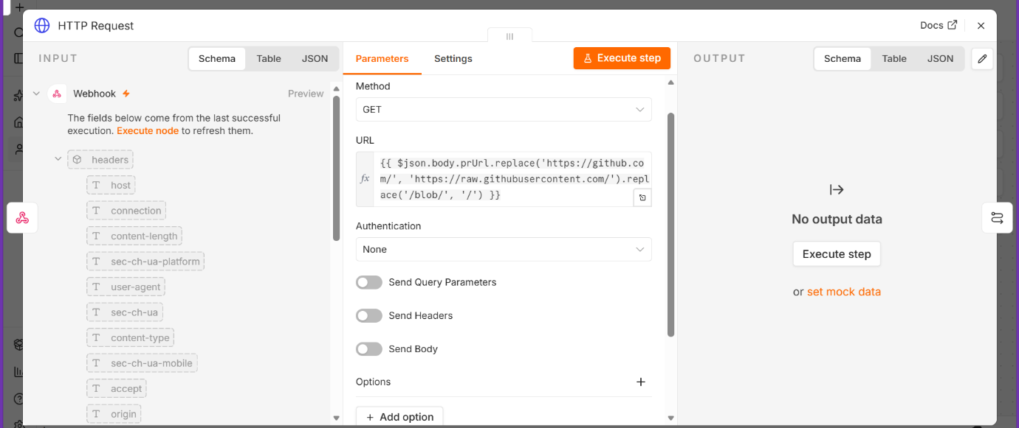
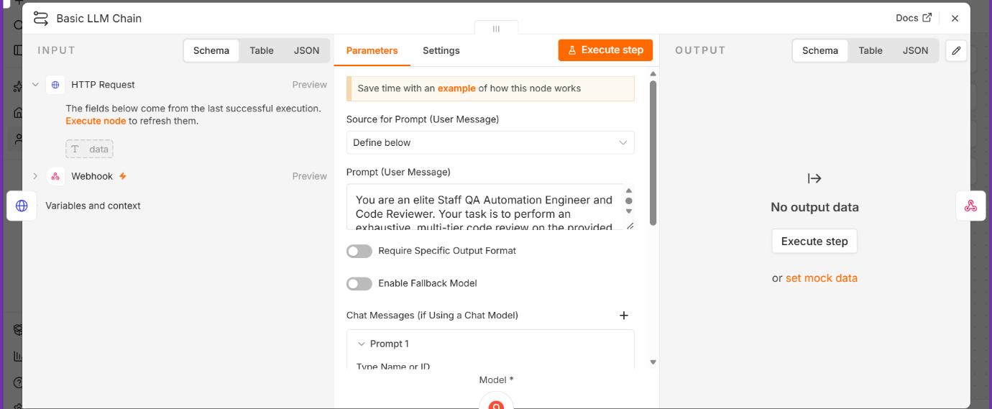
Prompt (User Message) in Basic LLM Chain:
You are an elite Staff QA Automation Engineer and Code Reviewer. Your task is to perform an exhaustive, multi-tier code review on the provided Selenium Java automation script.
Analyze the code across three critical vectors:
1. Security (Credential management, secure coding standards)
2. Performance & Reliability (Resource leaks, driver teardown, explicit/implicit wait optimization)
3. Code Quality (Naming conventions, structure, error handling robustness)
Output your evaluation strictly in a structured format so the downstream n8n nodes can parse it into JSON. You must provide:
- A numeric Security Score (0 to 100)
- A Performance Rating letter grade (A, B, C, D, or F)
- A Code Quality classification status (Excellent, Good, Needs Improvement, or Critical)
- A brief bulleted summary of findings
- An in-depth, line-by-line detailed feedback block formatted in clean Markdown snippets.
Ensure you explicitly look for dangling browser sessions, hardcoded credentials, and missing try-catch-finally isolation logic.
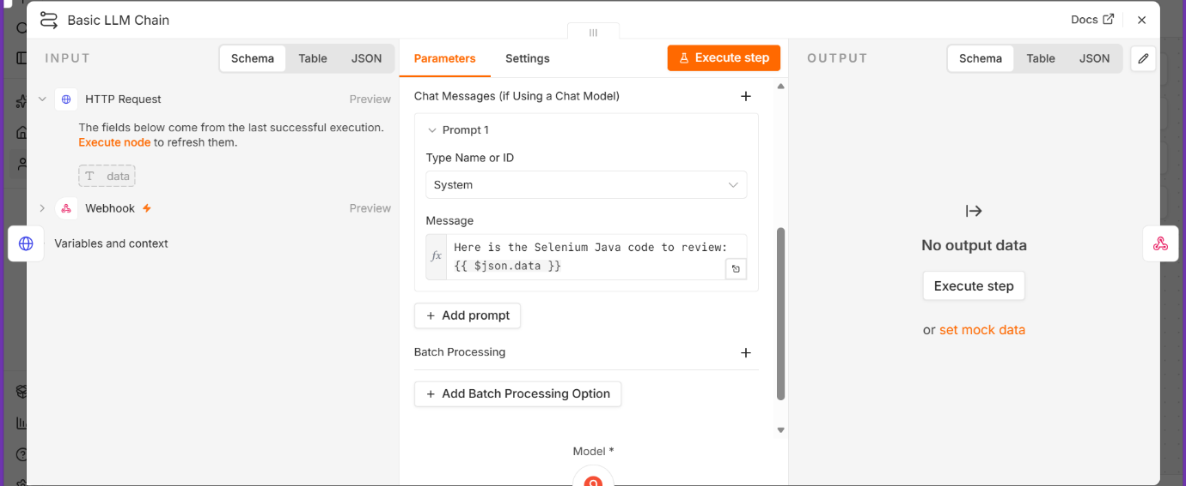
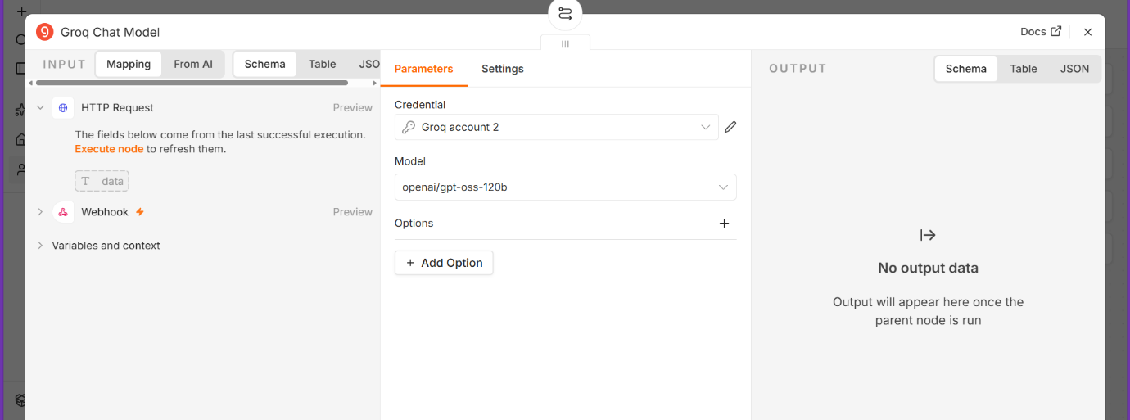
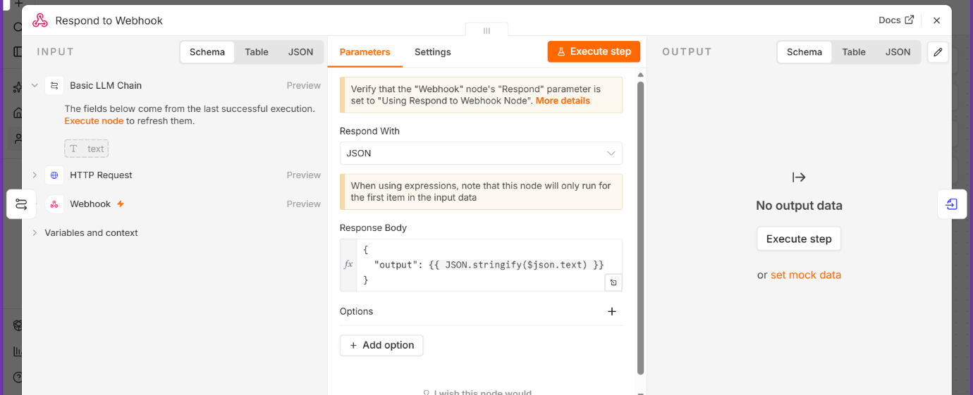
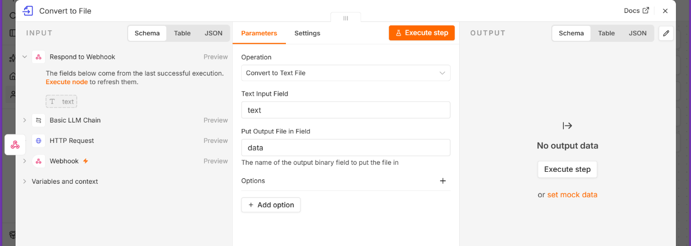
Prompt for Custom UI:
Act as an expert frontend engineer. Build a modern, clean, single-page React/Tailwind CSS dashboard for a GitHub Code Reviewer Agent.
Follow this phase-wise implementation plan:
Phase 1: Component Structure & UI State
- Create a layout with a dark-mode tech aesthetic (GitHub-inspired slate/gray tones) with Organization Name as Davidson & Co and designed a Logo based on Organization Name on Left side.
- Add an input form for a GitHub Repository URL or Pull Request URL, a dropdown to choose the programming language, and a "Run Review" button in Responsive Preview section.
- Create loading states (skeleton animations or progress tickers) and error states.
- Should be responsive for Desktop, Tablet & Mobile Devices (Both Android and iOS).
- Should have both Header and Footer.
Phase 2: Review Display Dashboard
- Design a split-screen or modular layout for the output.
- Left panel: Summary metrics (Security score, Performance rating, Code quality rating using visual badges).
- Right panel: Detailed feedback section that supports Markdown rendering for code snippets.
Phase 3: n8n Webhook Integration
- Add an asynchronous JavaScript fetch function that triggers on form submission.
- It must POST the form data as a JSON payload: { prUrl: value }
- The target endpoint should be the live n8n production URL: "http://localhost:5678/webhook/Code_Reviewer" (Note: match casing 'Code_Reviewer' exactly and do not use 'webhook-test' for live form submissions).
- Set headers to include 'Content-Type': 'application/json'.
- Handle the incoming JSON response returned by the "Respond to Webhook" node and map the output string directly to the UI elements created in Phase 1 & 2.
If the Search is blank, It should display proper error message. If the Search is not matches, then also should display error message.
If the Search matches, then should analyze the code and provide the exact score.
Strict phase rules Complete only one phase at a time. After Phase 1, stop and wait for your approval. Begin Phase 2 only after you explicitly approve Phase 1. Do not start the next phase without approval. Do not assume or generate unsupported requirements.
Phase-wise Implementation:
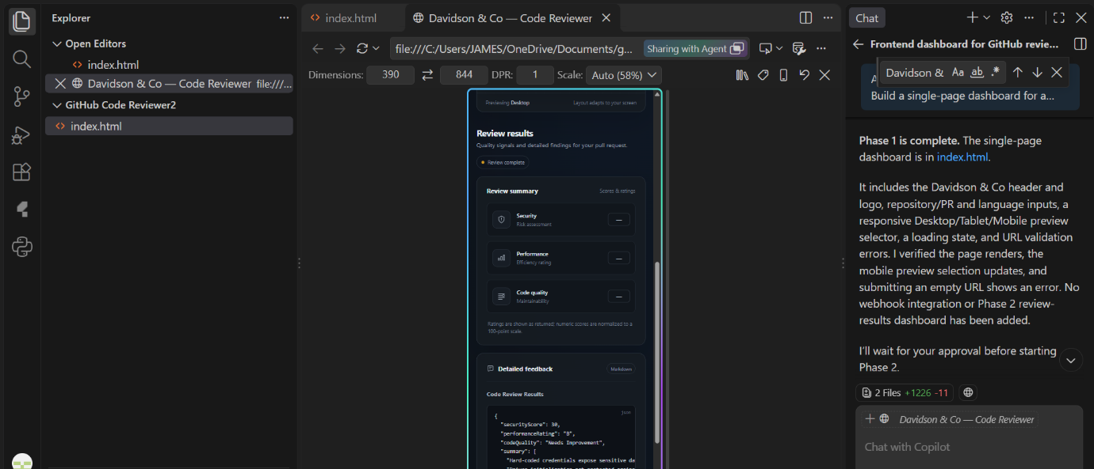
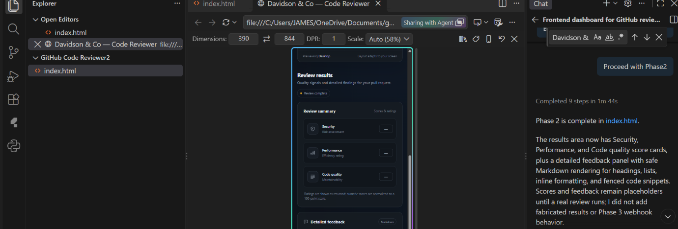
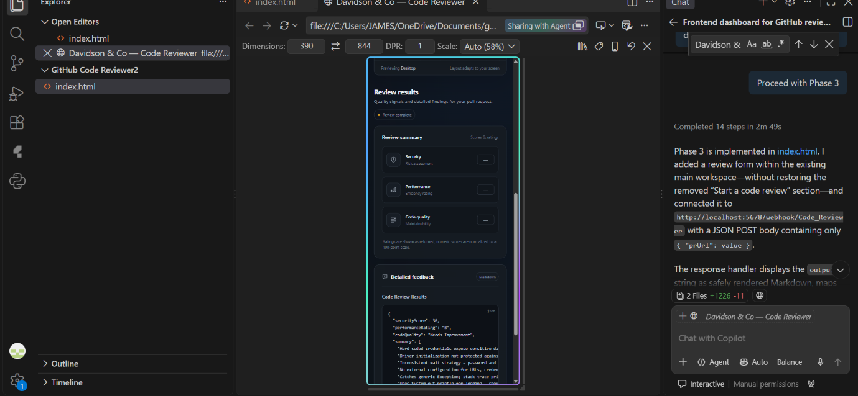
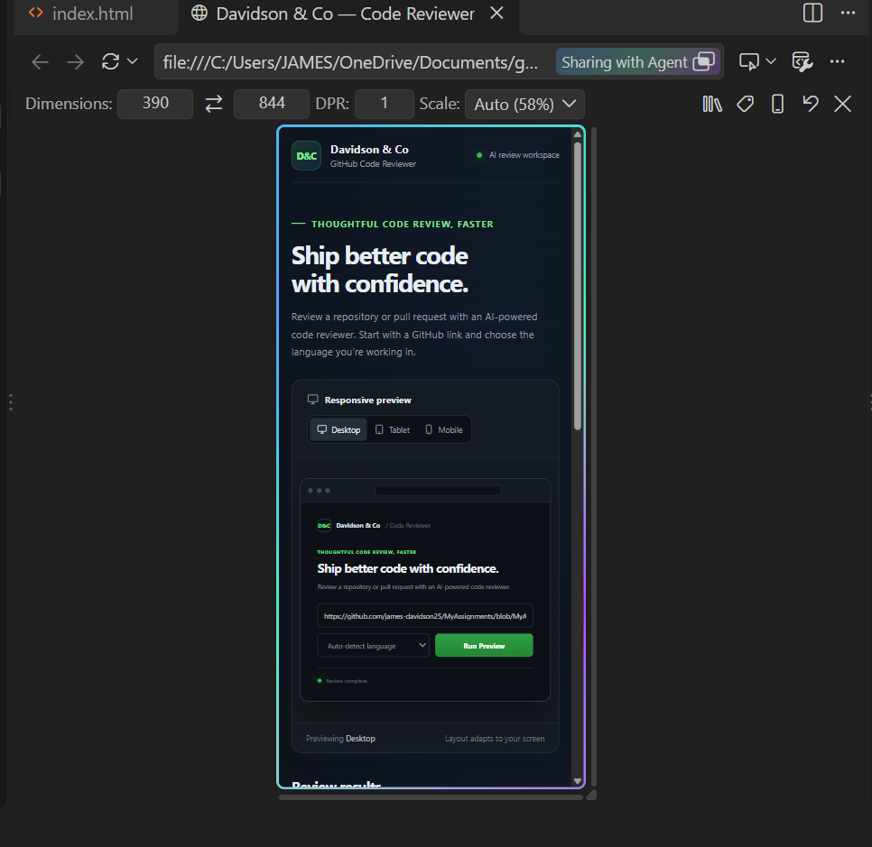
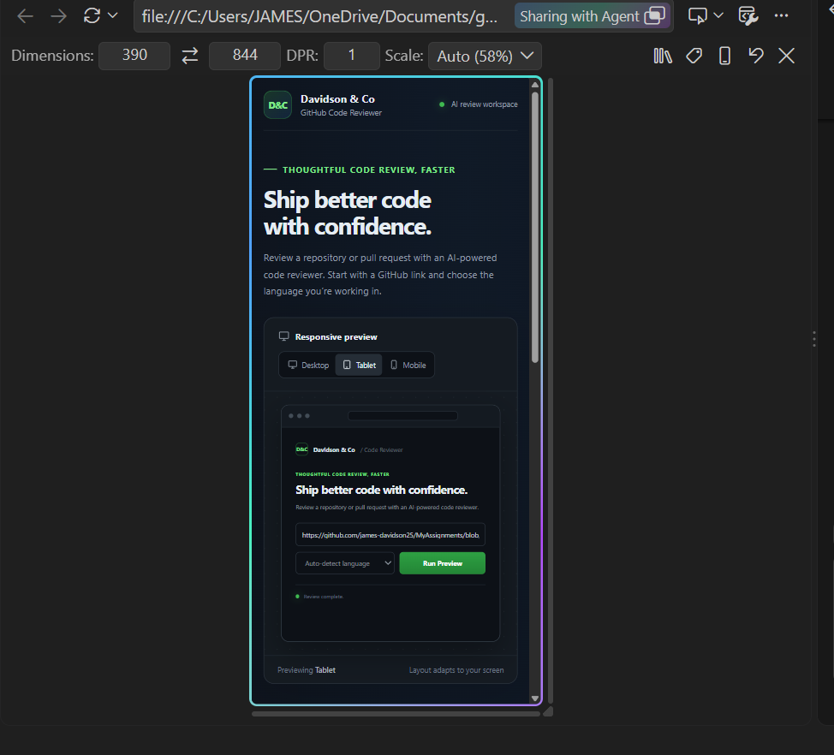
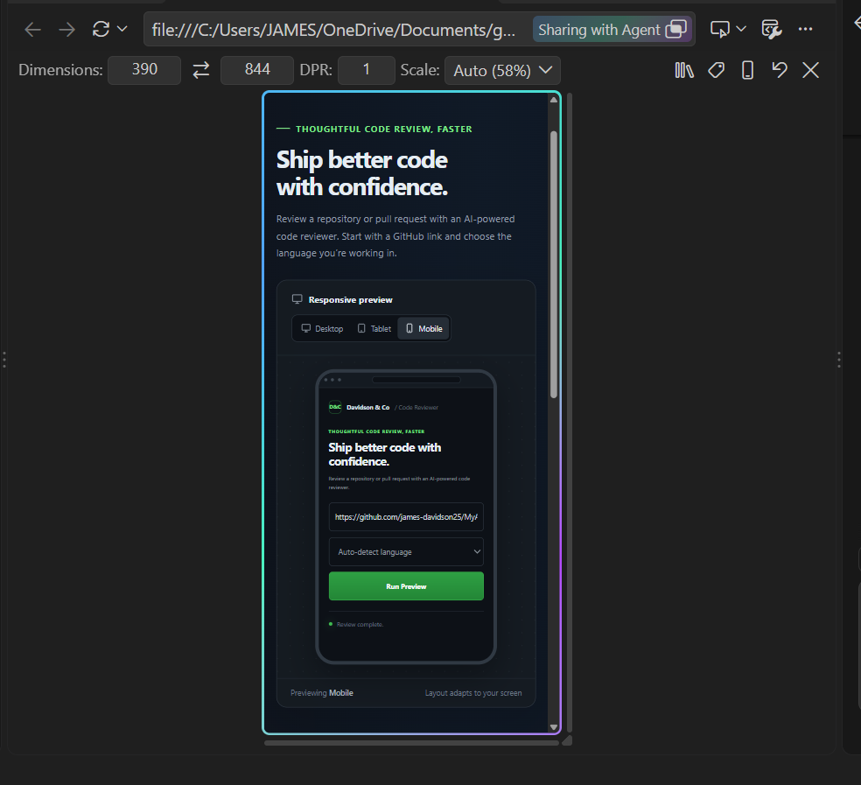
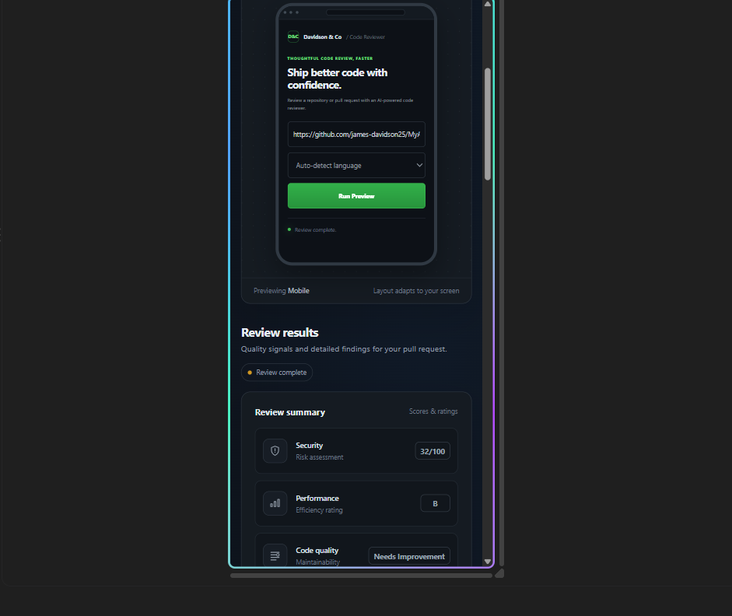
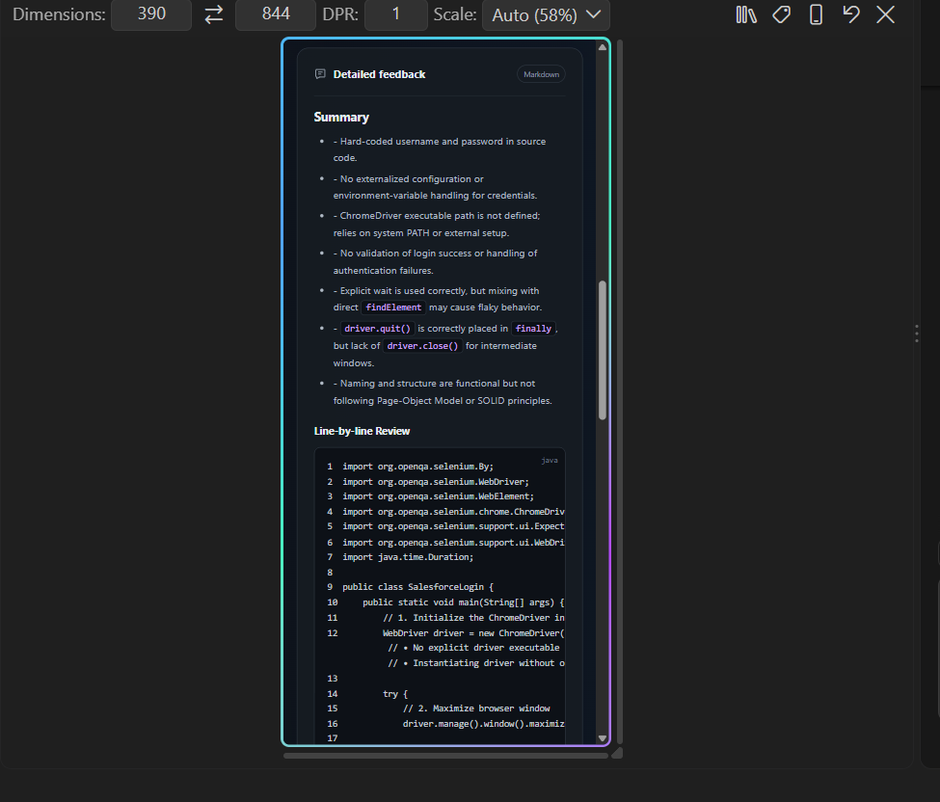
GitHub Repository URL:
https://github.com/james-davidson25/MyAssignments/blob/MyAssignments/SalesforceLoginTest.java
Index.html:
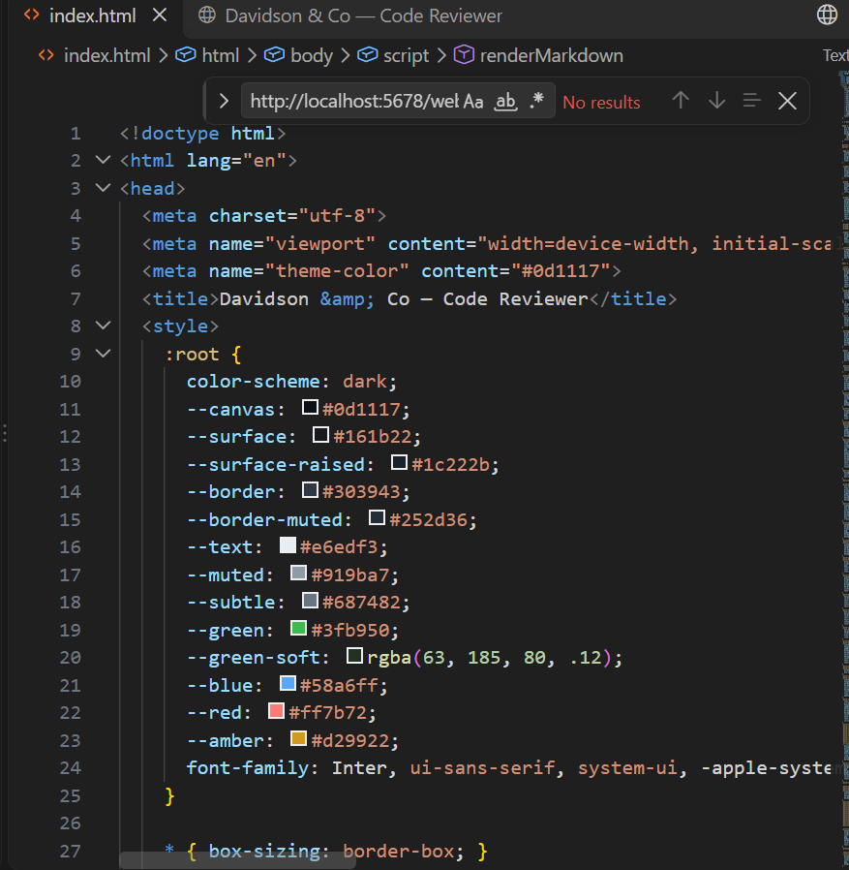

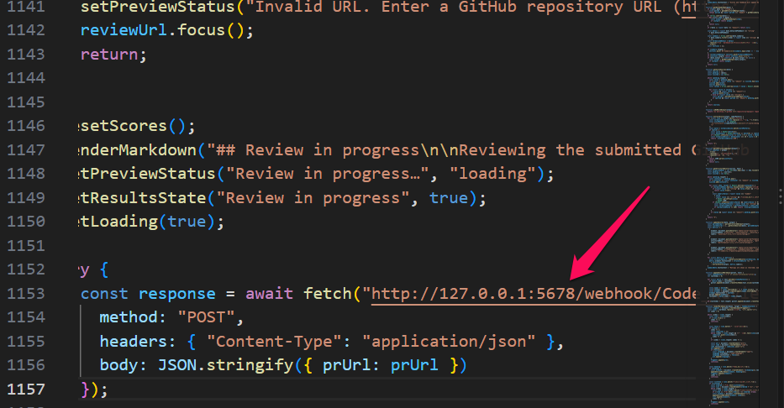
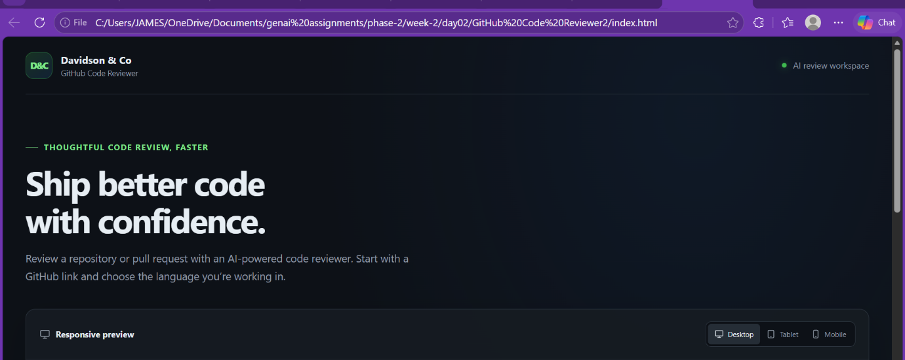
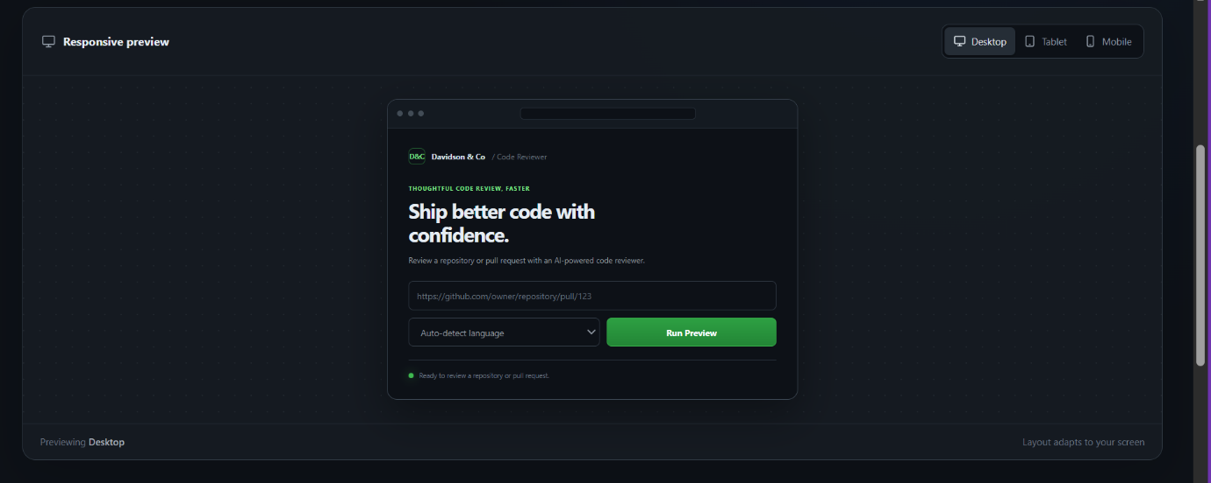
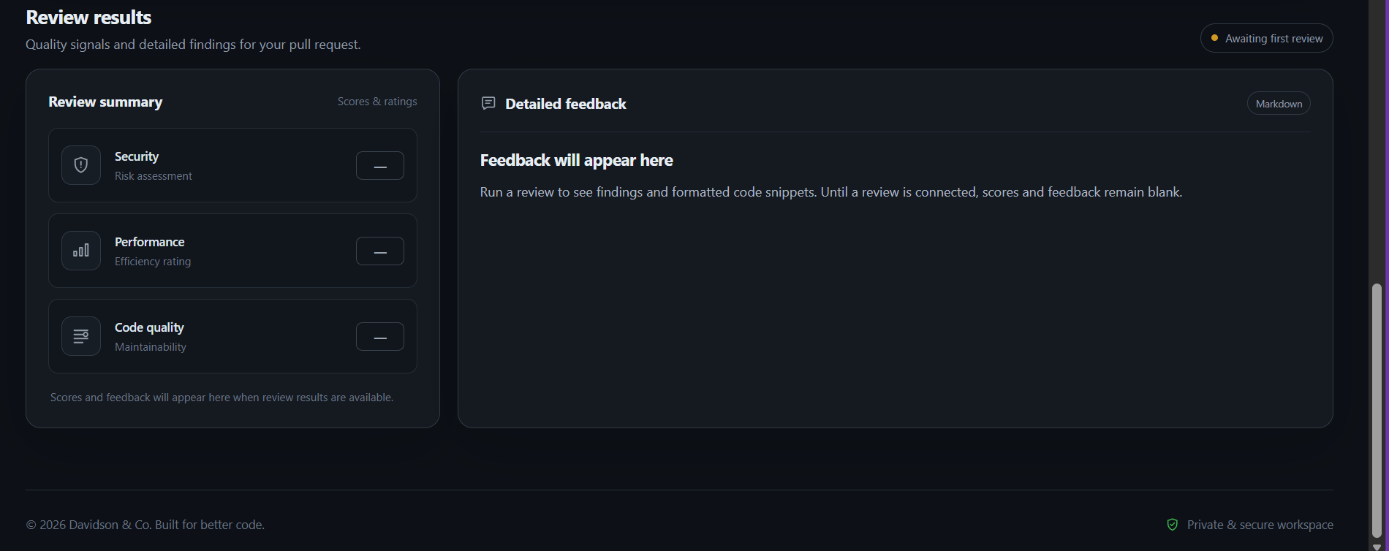
Local Server:
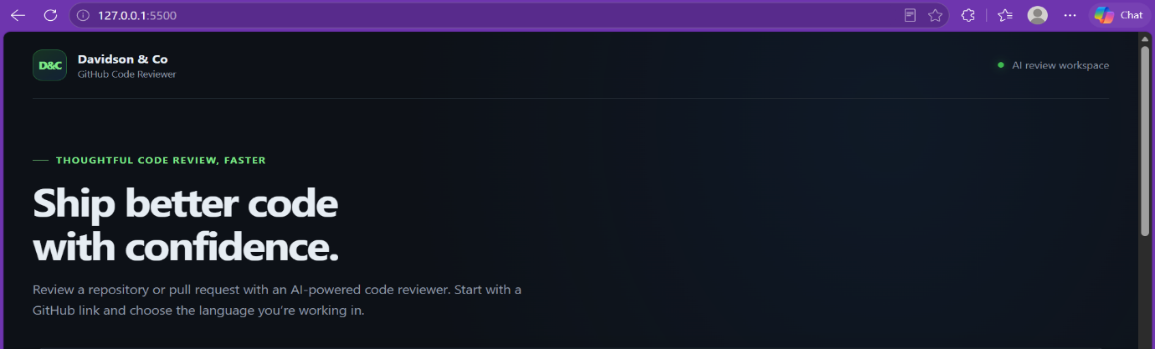
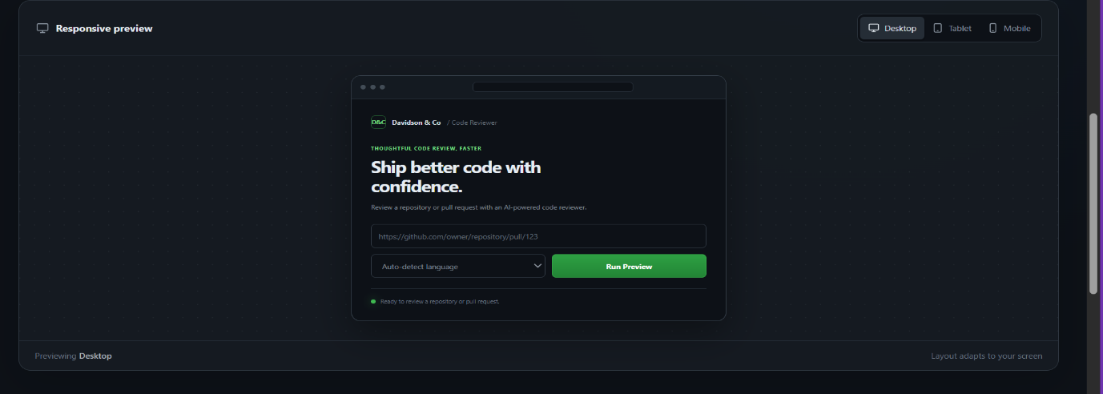
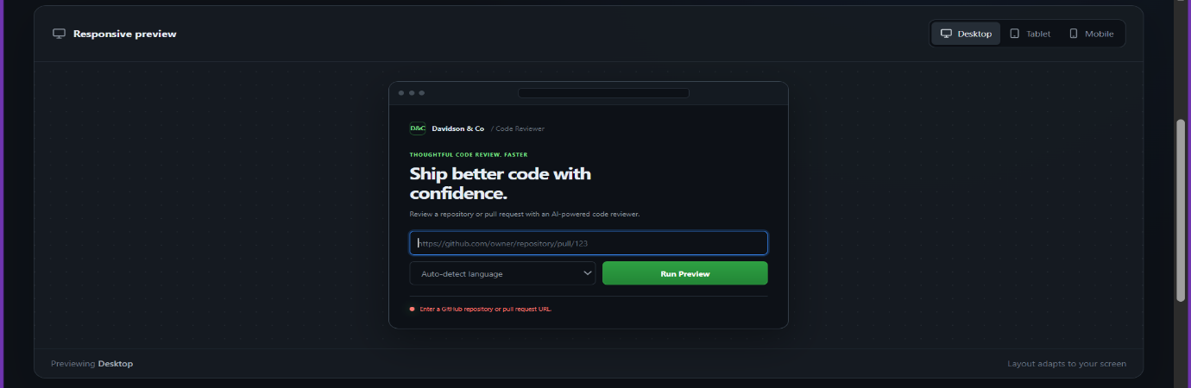
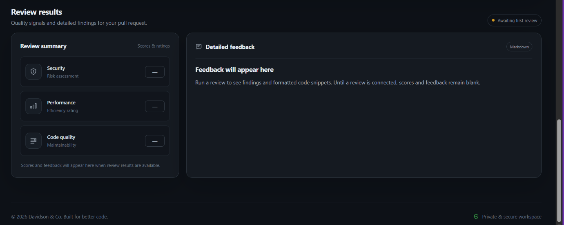
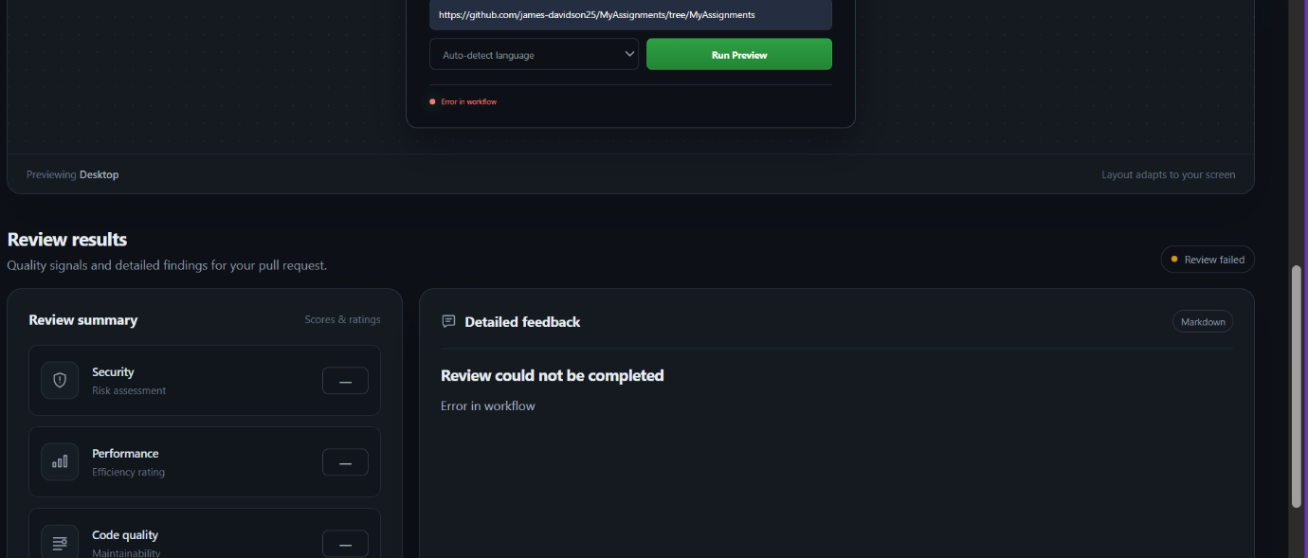
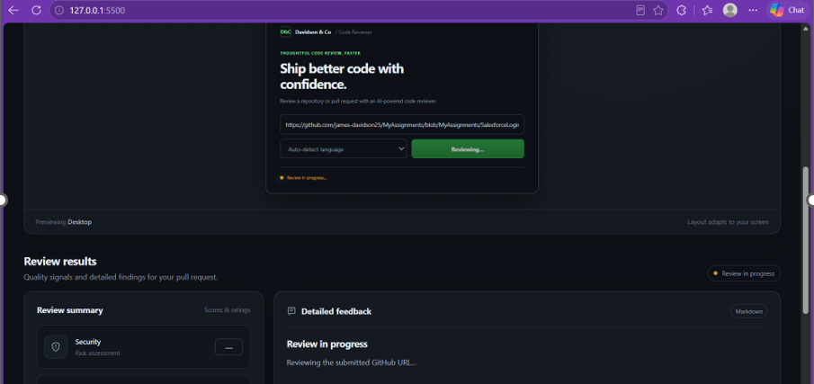
Mobile:

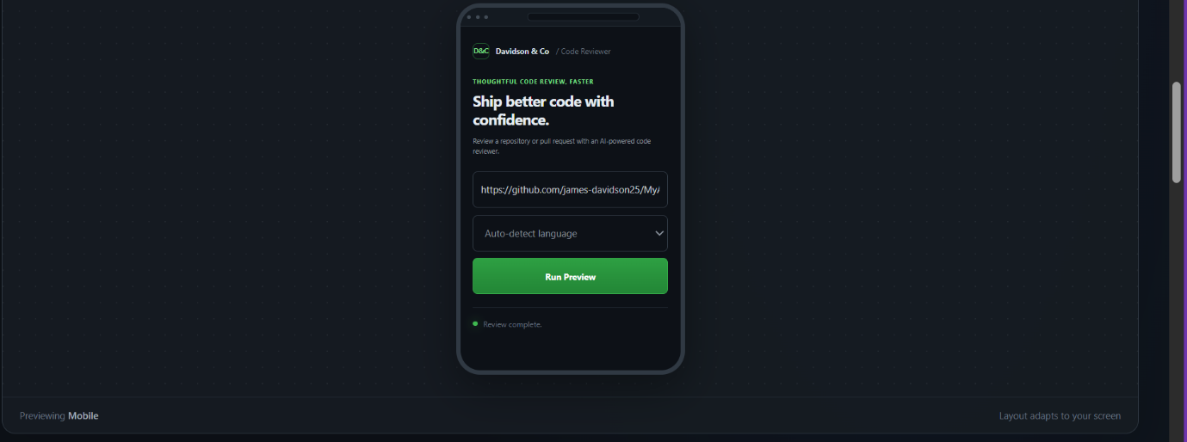
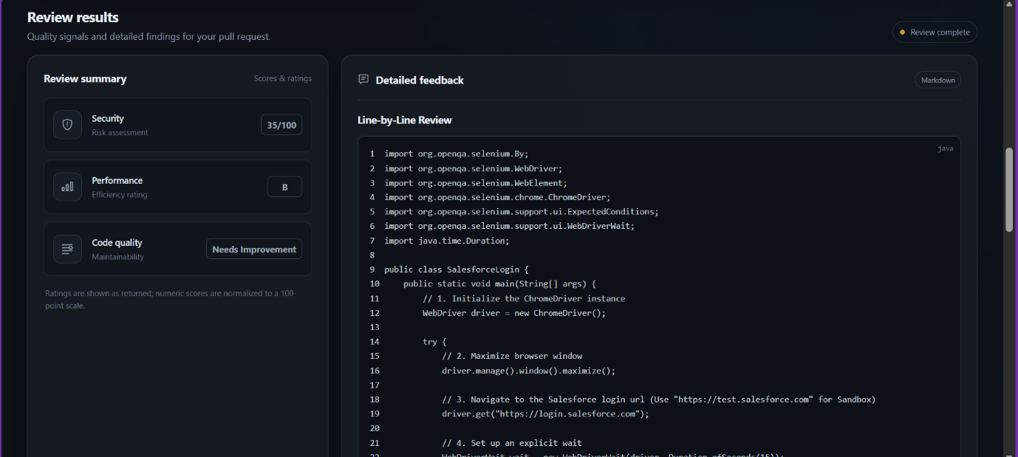
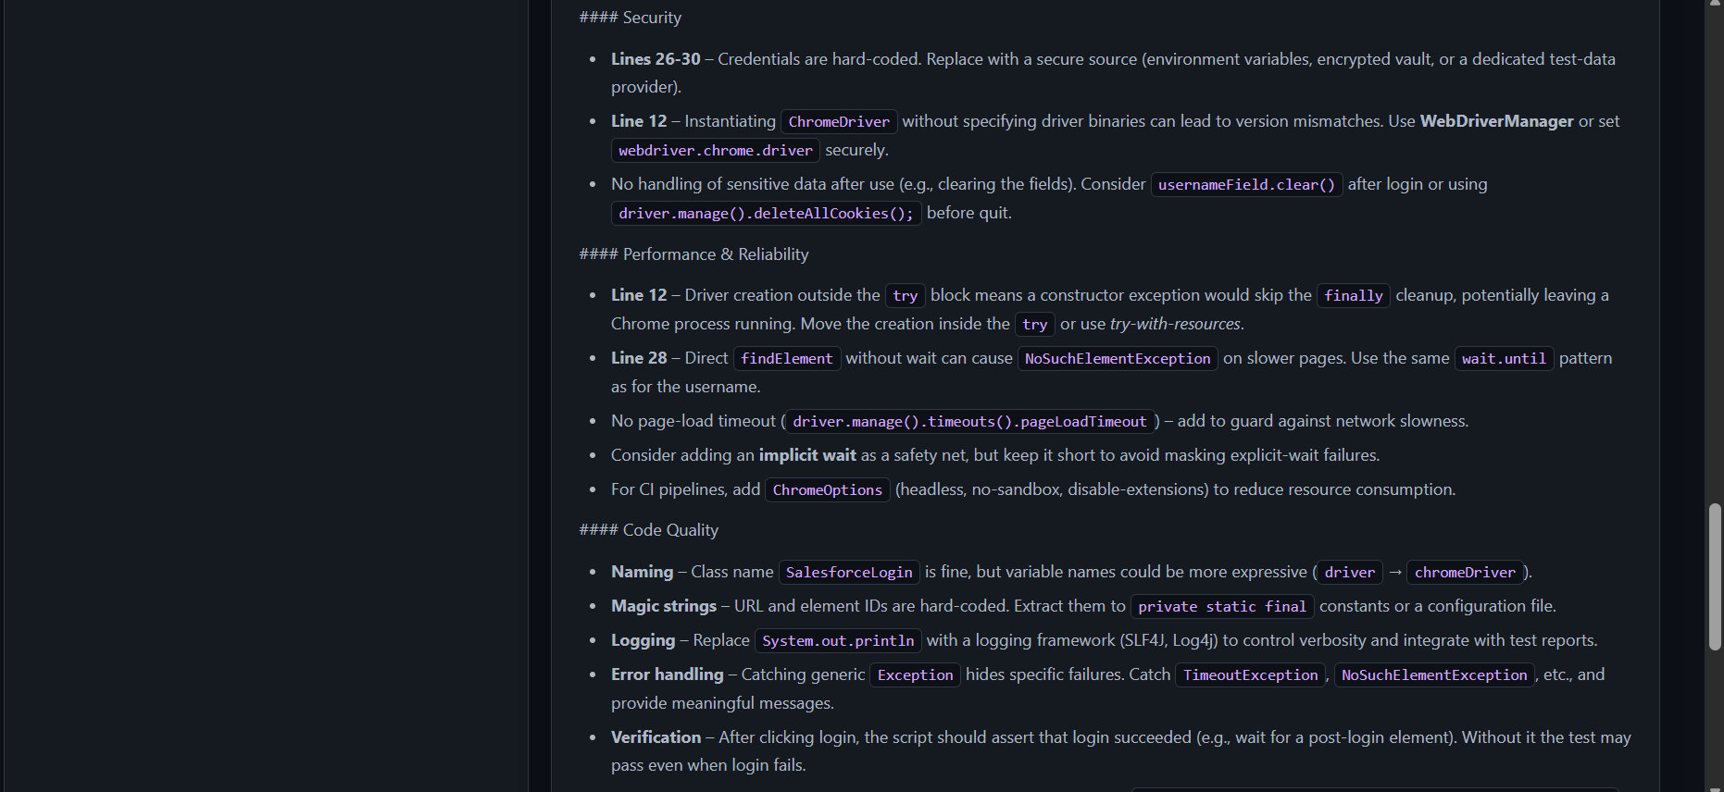
Desktop:
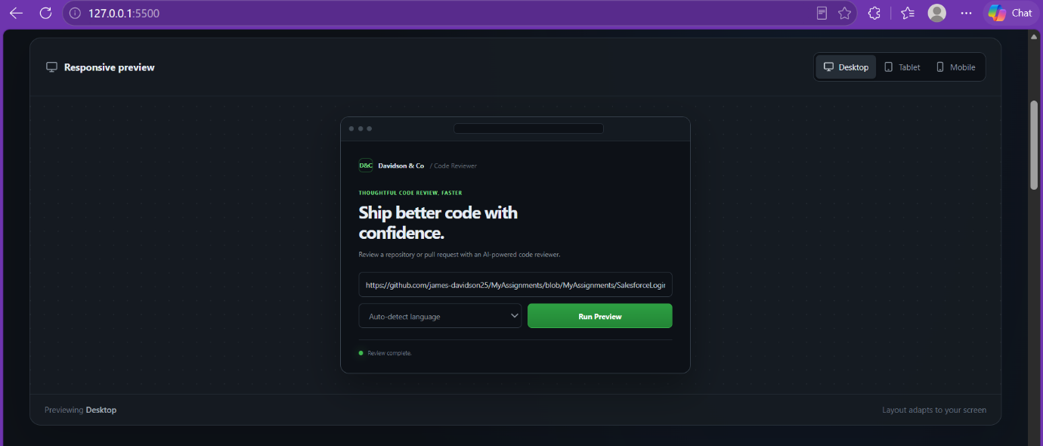
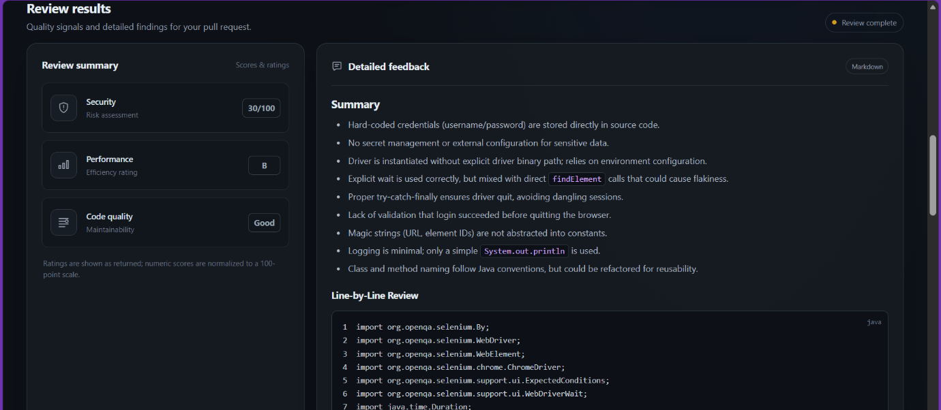
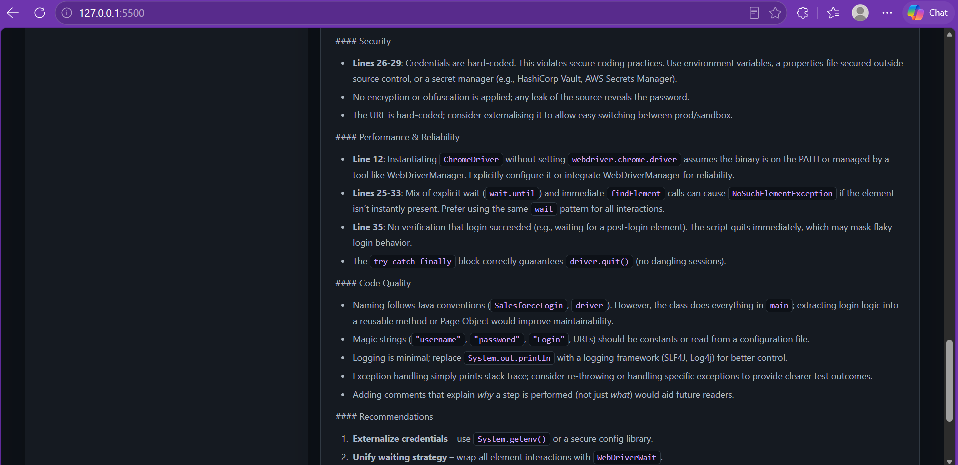
Tablet:
